**ASSIGNMENT TOP SHEET**

**Higher Diploma in Information Technology**

|  |  |
| --- | --- |
| Student Registration Number  SA23766228 | Student Name  N. Kasthury |
| Lab Group | PC number |
|  | NA |

|  |  |
| --- | --- |
| Module Time: Web Application Development | Module Code: |
| Lecture in charge: Dr Gayana Fernando | |
| Assignment Title: Project Proposal | |
| Due Date: 16th May | Date submitted:  16th May |
| Please tick here if you have proof-reader for this assignment: | |
| Turnitin Paper ID* | |

*Not required if not submitting via Turnitin

|  |  |
| --- | --- |
| **Declaration** | |
| I declare that work presented in the assignment submitted to the Sri Lanka Institute of Information Technology is a record of an original work done by myself. This assignment is submitted in the partial fulfilment of the requirement for the award of the degree of Bachelor of Science in Information Technology. The results embodied in this report have not been submitted to any other University or Institution for the award of any degree or diploma. Information derived from the published or unpublished work or others has been acknowledge in the text and a list of references is given. | |
| *Name(s) and*  *Signature(s):*  N. Kasthury | Date:  16th May |

**Extension Deadline**

Lecturer in charge agrees that the assignment may be submitted ……………………….. days after the deadline and should be marked without penalty.

Lecture in charge confirmation …………………………………………………………………………………………….

**TASTY TALES…**

**Sri Lankan authentic food restaurant.**

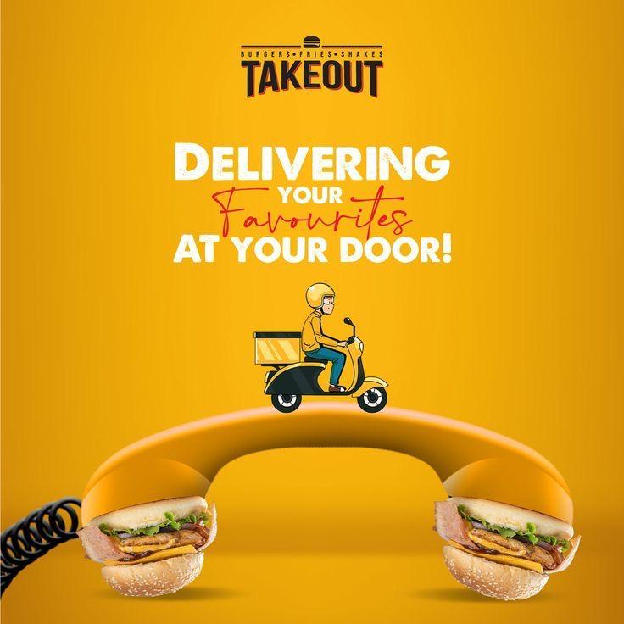

**Contents**

Web Application Development (Project Proposal)………………………………………………….. 1

1. Introduction and Description……………………………………………………………………………… 4
   1. Problem Specification…………………………………………………………………………………… 5
   2. Solution Outline……………………………………………………………………………………………. 6
      1. Software Specification………………………………………………………………………. 7
   3. Key Benefits………………………………………………………………………………………………….. 9
2. Details of System Functions ………………………………………………………………………………. 10
3. Conclusion…………………………………………………………………………………………………………. 12
4. Introduction and Description

Welcome to tasty tales, your passport to the enchanting world of Sri Lankan meals. start Culinary Adventure with us as we dive into the heart and soul of Sri Lanka’s diverse landscape

At tasty tales, we proud of ourselves On offering not just food ,but an experience stepped in tradition ,authenticity and the passion of srilankan cordiality . From the crowded streets of Colombo to the calm beach of Galle , each dish we serve carries with it is a story passed down through generations

Our chef passion and there experience will pop up every creation ,they make each bite is a flavourful disaster inside the mouth Whether You are foodie or food explorer tasty tales promises to deliver your sense and taste and Taste buds with extreme Flavors. welcome to tasty takes where every meal is a celebration of srilankan tradition

Description

Tasty Tales is offer user a wide range of food option .it is a colourful and perfect online platform that make users to get an srilankan food with they originality This application decide to give a good experience in finding they favourite foods in they comfort zone. This platform providing various types of Srilankan foods such as traditional tamil varieties include breakfast ,lunch, dinner, drinks and desert

* 1. **Problem Specification**

In order to give its users a flawless online experience, the Tasty Tales website attempts to address a number of important issues. First and foremost, accessibility is crucial. We're dedicated to making the website user-friendly for everyone, including those with disabilities, by providing features like information that is easy to read and screen reader compatibility. Furthermore, a layout that seamlessly adjusts to different screen sizes is necessary to accommodate the increasing number of visitors accessing the site via smartphones and tablets.  
Ordering should be as simple as possible, which means that a simple checkout procedure with customisable options and clear instructions is required. Maintaining an updated and well-organized menu necessitates effective administration, which calls for features like category, modifiable attributes, and real-time item availability updates.

* 1. **Solution Outline**

The Tasty Tales remedies that have been suggested take a thorough approach to resolving the issues that have been discovered. First, to ensure accessibility, features like keyboard navigation and alt text must be implemented while complying to web accessibility standards for diversity.

A responsive design approach will be used to achieve mobile responsiveness, making the website's layout as user-friendly as possible on various devices. To improve convenience, a user-friendly interface will shorten the ordering process and lead clients through a streamlined checkout procedure.

Adopting a content management system is necessary for efficient menu administration in order to organize and update menu items. Reputable gateways for secure payment integration will protect transactions, while comment areas and rating widgets for customer input will promote user interaction and ongoing development. Finally,

* + 1. **Software Specification**
* Front-end (Client-side):
* HTML
* CSS
* JavaScript
* Ajax
* Back-end (Server-side):
* PHP
* Database Interaction:
* SQL (Structured Query Language)
* Development Platforms:
* Adobe Dreamweaver – primarily used for frontend development

(HTML, CSS, JavaScript)

* Wamp Server – provides a local server environment for backend development (PHP) and testing
* Data Storage:
* MySQL DB – used as the backend database management system

(DBMS) for storing and retrieving data.

Analysis

Operation & Maintenance

Testing & Integration

Implementation

Design

Requirement

Specifications

* 1. **Key Benefits**

Improved Accessibility: By adding accessibility features, the website makes sure that all users, regardless of their limits or impairments, may use it inclusively.

Effortless Mobile Experience: The website's responsive design ensures that it displays consistently and is easy to use on a range of screen sizes and devices.

Streamlined Ordering Process: When clients place purchases online, a user-friendly ordering interface makes the checkout process more efficient, lowering friction and increasing convenience.

Menu Management-The menu is kept current and organised by using a content management system, which makes updating and organising menu items simple.

Payment: Integrating with trustworthy payment gateways ensures the security of online transactions, giving clients peace of mind and confidence when they make purchases.

1. **Details of System Functions**

**1. User Registration and Authentication:**

* Users can create accounts by providing basic information like name, email, and password.
* Upon registration, users receive a verification email to confirm their account.

**2. Browsing Menu:**

* Users can browse through the menu categories, including appetizers, main courses, desserts, and beverages.
* Each menu item is accompanied by a description, price, and possibly a photo to help users make informed decisions.

**4. Adding Items to Cart:**

* Users can add items to their cart with a single click.
* The cart displays a summary of selected items, quantities, and total cost, allowing users to review and make adjustments before proceeding to checkout.

**3. Payment Processing:**

* Secure payment gateways are integrated to facilitate online transactions.
* Users can choose from various payment methods such as credit/debit cards, digital wallets, or cash on delivery.
* Payment information is encrypted to ensure confidentiality and security.

**3.Conclusion**

Tasty Tales is positioned to transform the internet eating landscape by providing a smooth and easy-to-use platform that allows patrons to discover, purchase, and savour genuine Sri Lankan dishes. Tasty Tales wants to build an efficient, user-friendly, and inclusive online environment that meets the wide range of demands of its clients by tackling important issues and putting strong solutions in place.

Every element of the Tasty Tales website is made with the client in mind, from improved accessibility features to expedited ordering procedures and safe payment integration. Features like menu browsing, search and filter options, and helpful feedback mechanisms further enhance the user experience and make sure that every engagement with the platform is enjoyable.